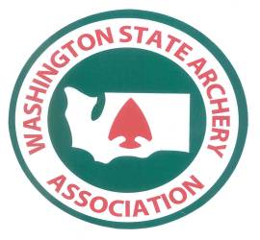

Third Annual
National Archery in the Schools Program
Washington State Championship

WHERE
Clovis Point Middle School, 1855 4th St SE, East Wenatchee WA

WHEN
The tournament will be conducted on Saturday 12 April 2008. Participating schools (archers) will select or be assigned (as space permits) one of three shooting times or flights:

Flight #1 – 9:00 am Flight #2 -- 12:00 noon (If needed) Flight #3 -- 3:00 pm

WHO
This tournament is the annual event for schools participating in the Washington NASP. The basic foundation of the NASP is the in-school archery unit. Therefore, schools that teach archery as part of the in-school curriculum are qualified to compete in this tournament. This tournament is not for schools or clubs that offer archery only as an after-school activity.

Team members must come from a single school, not a school district or multiple schools, except a student in a lower grade may shoot for a team in his or her school district that is in a higher Division but not vice versa.

Teams and individuals will register in either the Elementary (K-6th grade),
Middle (7-8th grade), or High School (9-12th grade) Division. Team competition will be among schools with 12 or more archers. Students may compete for individual awards if their school cannot field a 12 person team.
To maximize school participation, registration is limited to no more than 20 archers per School / Division.

REGISTRATION:
Registration will be handled by Washington State Archery Association
Registration window: 15 February 2008 – 1 April 2008.
Email pre-registration to: wsaa@olynet.com to reserve space on your desired flight
The registration fee is $10 / student payable by check to the WSAA by mail or on site.

FORMAT
Qualified Equipment:
- NASP Genesis compound bow (target colors or camouflage).
- Full-length, size 1820 aluminum arrows.
- No sights, tape, marks, or other modifications to the bow that may, in the opinion of the judges be used as a sighting aid.

Range Set-Up:
Targets will be 80 cm FITA face with 10 scoring rings.
Competition Format
Each archer will shoot 1 practice end of 5 arrows at 10 meters.
Each archer will shoot 3 ends of 5 arrows (total of 15 shots) at 10 meters.
Each archer will shoot 1 practice end of 5 arrows at 15 meters.
Each archer will shoot 3 ends of 5 arrows (total of 15 shots) at 15 meters.
Time limit per end will be 2 minutes beginning with the 1 whistle "shoot" command.

AWARDS
Washington State Championship Awards:
- Team awards will be presented for the 1st-3rd highest scoring teams in the Elementary (K-6), Middle (7-8), and High School (9-12) Divisions.
- Team scores will be the sum of the scores shot by 4 highest girls and 4 highest boys and the next 4 overall from each school in each of the three divisions during the tournament.
- Individual awards will be presented to the top five boys and girls in each Division.
- Presentation of Awards is planned for 3:00 PM (6:00 PM if 3:00 PM line is needed).

Location of Washington NASP Championship:
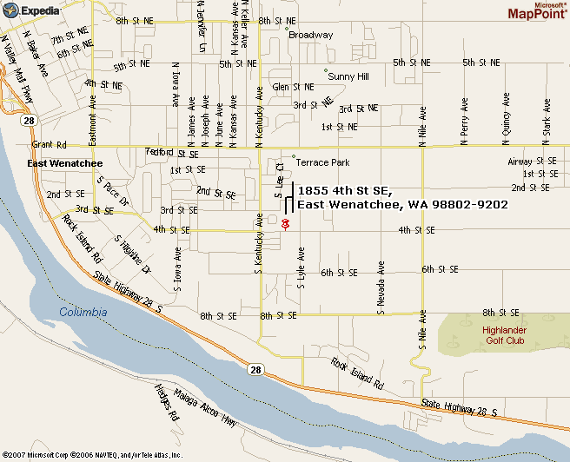
Clovis Point Middle School
1855 4th St. SE
East Wenatchee

