Make PE Days, Healthy Days
by Carol Goodrow
HEALTHY DAYS
It's great to think that kids will be inspired and under your influence every day of the week and certainly that should be a long term goal, but it's more practical to start with small goals. Choose the two days that you actually work with your children, and aspire to make these days be "Healthy Days". A great way to reach this goal is to have children record healthy habits in a PE/HOME journal.
IN GYM CLASS
It's 10:00 when the children enter the room, but it takes time for attendance, introducing your lesson, making sure shoes are tied, and the clock is ticking away. The kids haven't even started to warm up yet. By 10:25, each student needs to be back in the classroom, cooled down, with thirst quenched, layers back on and ready for math. There's not a minute for extras, but now the demand is high to integrate literacy and/or math skills in the PE classroom. Just how can this be done without deeply cutting the moments spent with physical activity?
To be sure, young kids don't have the time to keep a detailed diary in PE class with summaries, thoughts, and goals; at least not with the time constraints that PE classes are now working under but a simple school/home log might work for you. Here are a few simple ideas which can be used so that kids can "journal" in PE.
PE/HOME LOG
1. Prepare a journal made of log pages which can be carried with them, from home and back to school on PE days.
2. Have them record physical activity in a block which requires only one sentence (or less) for each gym period. Kids can copy from a board or they can create their own brief entry.
Keep the writing "age graded". The youngest kids write just one word in their daily entry. Example: "Relay" Older children write a sentence, "We had fun with relay races in the gym."
2. Use a color-in time tracker. Try a circle divided into sixths (one wedge for each 10 minutes exercising). Kids color in 2 sections for exercising for 20 minutes at end of gym period. They carry this with them and color in another 2 after recess. It's clear and simple. The goal is for kids to stay active for another 2 10-minute periods at home, bringing the total to one hour. Quick discussions can relate these diagrams to time, fractions, and data analysis, depending on the age level.

3. Add a healthy food award square. Divide it into fourths. Kids can reward themselves with smile faces, stars, etc. for each fruit, vegetable, or other healthy food eaten during the day. Use it to add a little writing or art, by writing or drawing the healthy foods eaten.
RESPONSIBILITY
Kids carry their journals with them to and from PE class and home, just as a homework agenda. Have extra "log" sheets on hand for kids who forget journals so that they can always be filling in PE data.
ABOUT THE AUTHOR
Carol Goodrow is the founding editor of KidsRunning.Com, a Runner's World Micro site. As a classroom teacher, she has had a running program for seven years, in which journal writing and math has been a strong component. This spring, she will be leading a fitness/academic club with 85 first and second graders, and 60 parents. The children will walk/run, collect math data on various topics (miles covered, weather, length of shoelaces, etc.), and then children, with parents by their sides, will use Carol's new book Happy Feet, Healthy Food, Your Child's First Journal of Exercise and Healthy Eating, to record: physical activity, time exercised, healthy snacks, and more. You can contact Carol at kidsrunning@hotmail.com.

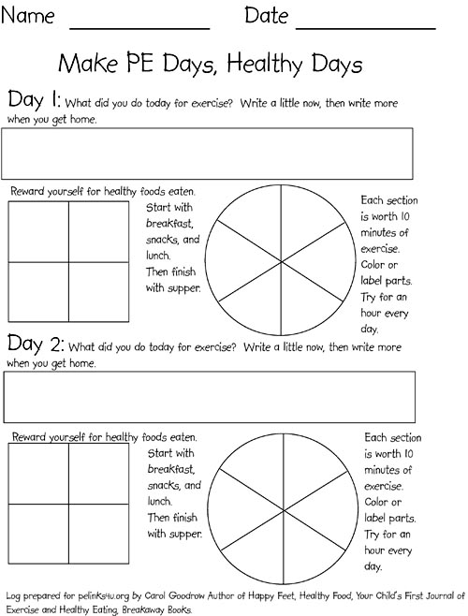

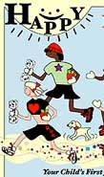 HAPPY FEET, HEALTHY FOOD
Your Child’s First Journal of Exercise and Healthy Eating
Written and Illustrated by Carol Goodrow
“Others will soon wake up and produce more books and videos to encourage kids’ fitness, but this will always be the first, and I dare say it will be difficult for anyone else to improve upon it.”
—Amby Burfoot, Executive Editor of Runner’s World, and 1968 Boston Marathon winner
An epidemic of childhood obesity is in the news almost daily. Parents who want to become more involved in their children’s health now have help: Happy Feet, Healthy Food. It’s informative, easy to use, geared specifically to children, and just good plain fun. It’s a simple daily journal that can heighten awareness of what kids eat and how much they exercise, while gently suggesting different activities they could try.
Happy Feet, Healthy Food is a combination of logbook (to record exercise and diet) and a sourcebook for exercise, activities, and eating tips. Each week features bright color illustrations, lists of activities, advice on good foods, recipes, and suggestions for packing snacks and lunches, and a journal page to write about the activities of each day and foods eaten. The goal is to promote understanding of the benefits of exercise and healthy eating, to improve the child's reading and writing skills, and to foster dialogue with parents. Perfect for use in schools or at home, it celebrates the joyful, supportive relationship that parents and kids can have through sports. It points the way forward in life for happy, healthy, active kids.
Carol Goodrow is the founding editor of Kidsrunning.com, a Runner’s World site, which has won numerous awards for its creative and informative content. She is also an award-winning elementary school teacher in Tolland, Connecticut.
Contact Garth Battista: Garth@breakawaybooks.com / (607) 326-4805 / (800) 548-4348
Or contact Carol Goodrow directly: goodrow@infionline.net / (508) 347-7825
ISBN: 1-891369-46-6. Library of Congress Control Number: 2003116286
112 pages, hardcover, $14. Full-color throughout. For ages 6-12.
Distributed to the trade by CONSORTIUM; 1045 Westgate Drive; St. Paul, MN 55114.
Publication date: May 10, 2004

