Energy Management (Athlete Handout)

Introduction
- Energy management has to do with helping you control your arousal- the _______________ and __________ energy that fuels your athletic performance.
- This energy is on a continuum from deep sleep to intense excitement.
- Arousal involves both how much the _______ is activated and how that activation is _____________. It’s the body’s way of preparing for intense, vigorous activity.
- You have more or less arousal at different times of the day and in different situations.

Put the following on the arousal continuum: sleep, practice, watching TV, playing in a state tournament game, sitting in this session.

Low Moderate High

- When you are physically aroused complex changes happen in your body. Have you ever heard of the fight or flight response?
- Did you ever get butterflies in your stomach…. have to run to the bathroom….?
- Two reasons understanding arousal is important:
- Physical symptoms are normal and signal readiness to compete- nothing to worry about.
- Athletes with elevated arousal deal with it in various ways- pacing, talking incessantly, screaming… while some yawn, nap. Both approaches can be effective in controlling arousal.
- So, each person must find an energy management strategy that works for her to attain optimal arousal in practice and competition.
- How does arousal affect performance?

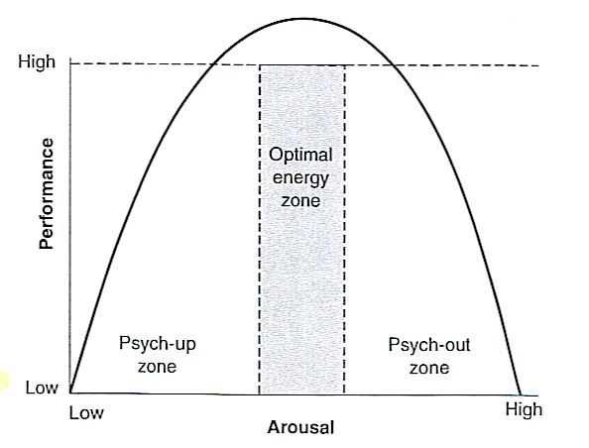
From D. Burton and T. Raedeke, 2008, Sport Psychology for Coaches (Champaign, IL: Human Kinetics).

- Arousal too l___: you’ll lack sufficient physical and mental e_____ to perform to your best.
- Arousal too h______: you’ll suffer from a variety of problems related to t______, attention, motor control and interpretation that prevent you from performing your best.
- Athletes have different optimal energy z_______. How do you figure out your optimal energy zone?
- Know your personality and athletic ability.
- Know what you need to do in your sport position.
- Use the Arousal Monitoring Scale: assign yourself a score repeatedly during practice (and later during competition), and over time you’ll discover what optimal arousal (5) feels like for you in various situations and be able to play more consistently in zone 4-6.
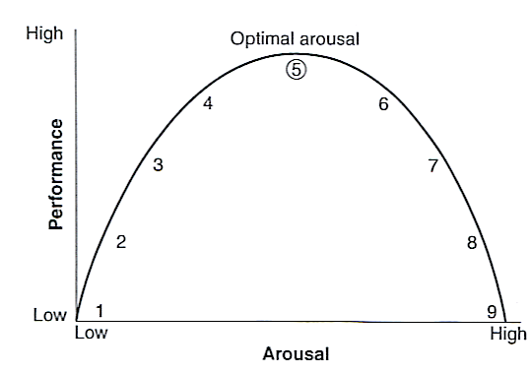
From D. Burton and T. Raedeke, 2008, Sport Psychology for Coaches (Champaign, IL: Human Kinetics).
- If you are not in your zone, you can do rapid relaxation to lower arousal or energization to increase arousal.
- Mental side of arousal: how you ___________ physical changes has a huge effect on how you perform.
- If you interpret arousal ___________, as challenge, readiness or excitement, you can experience top performance and flow.
- If you interpret it ____________, you are likely to perform poorly.
- If you start to experience self-doubt, loss of control or images of failure, use mental training tools to get self back in zone. First r_______ completely in order to lower arousal. Then use s_____ - ________ to reinterpret your arousal constructively and rebuild self-confidence. Then use energization s_______ to raise arousal back to your optimal energy zone.
- List 3 different skills you do in your sport position and then check if each requires low or high arousal:

Skill | Low | High

- As you consider your personality, do you generally need to increase or decrease your arousal level to get into your optimal energy zone for competing?
__________ Increase ___________ Decrease (Check one)

- Think back to a competition where your performance seemed to go up or down depending on what you were thinking and feeling. Write a bit about what happened……

- During practices, check yourself on the Arousal Monitoring Scale. Use relaxation or energization as needed.

