Psychological Skills Training: Energy Management
written by Dr. Christine Lottes

Athletes need to manage both their physical and mental arousal levels. Continuing our Psychological Skills Training series in pelinks4u, today’s article provides a script for the coach, and, 2 reproducible handouts (one a script for the coach plus a handout for athletes) as we look at how athletes can successfully manage their physical and mental energy for optimal athletic performance.

Coach’s Script for: Energy Management

Bring to practice: coach’s script, a copy of the athlete’s handout for each athlete
(follows coach’s script), pencils or pens, chalk or dry board markers

Energy Management

Take: booklets, pencils, notebook, chalk or markers

Today: Energy Management

Introduction
- Energy management has to do with helping you control your arousal- the physical and mental energy that fuels your athletic performance.
- This energy is on a continuum from deep sleep to intense excitement.
- Arousal involves both how much the body is activated and how that activation is interpreted. It’s the body’s way of preparing for intense, vigorous activity.
- You have more or less arousal at different times of the day and in different situations.
- Put the following on the arousal continuum: sleep, practice, watching TV, playing in a state tournament game, sitting in this session.

State
Sleep TV Sitting in session practice Game

Low Moderate High

- When you are physically aroused complex changes happen in your body. Have you ever heard of the fight or flight response? (heart rate increases, breathing increases, adrenaline and other hormones released, etc). All gets you ready for physical action.
- Did you ever get butterflies in your stomach? That’s because of decreased blood flow to the digestive system….. your body diverts the blood to where it’s needed and away from the stomach…. bladder empties making for plenty of trips to the bathroom….. blood flow to extremities slows down so your hands and feet get cold…..
- Two reasons understanding arousal is important:
- physical symptoms are normal and signal readiness to compete- nothing to worry about.
- Athletes with elevated arousal deal with it in various ways- pacing, talking incessantly, screaming… while some yawn, nap. Both approaches can be effective in controlling arousal.
- So, each person must find an energy management strategy that works for her to attain optimal arousal in practice and competition.
- How does arousal affect performance?
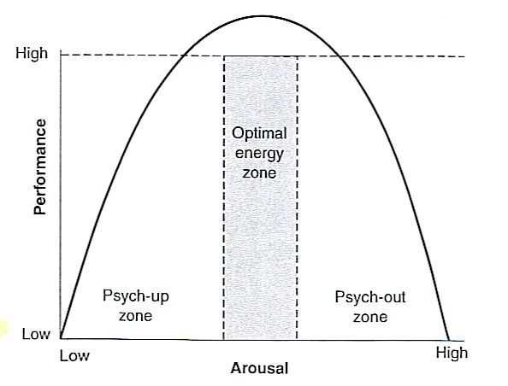
From D. Burton and T. Raedeke, 2008, Sport Psychology for Coaches (Champaign, IL: Human Kinetics).

- Arousal too low: you’ll lack sufficient physical and mental energy to perform to your best.
- Arousal too high: you’ll suffer from a variety of problems related to tension, attention, motor control and interpretation that prevent you from performing your best.
- You want moderate arousal.
- Athletes have different optimal energy zones.
- How do you figure out your optimal energy zone?
- Know your personality and athletic ability- introvert vs. extrovert; how much athletic ability; how long does it take me to get ready mentally; how do I respond to outside circumstances and people?
- Know what you need to do in your sport position- running full out doesn’t take much precision but (coach- change the following skills to skills from your sport) tackling, passing and shooting do.
- Use the Arousal Monitoring Scale: assign yourself a score repeatedly during practice (and later during competition), and over time you’ll discover what optimal arousal (5) feels like for you in various situations and be able to play more consistently in zone 4-6.

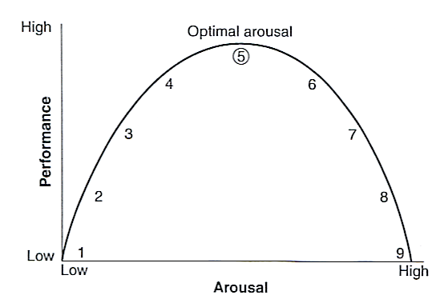
From D. Burton and T. Raedeke, 2008, Sport Psychology for Coaches (Champaign, IL: Human Kinetics).

- If you are not in your zone, you can do rapid relaxation to lower arousal or energization to increase arousal.
- Mental side of arousal: how you interpret physical changes (butterflies in stomach as a sign of excitement and anticipation of the competition to come.. or….as a cause for worry and anxiety about how going to perform) has a huge effect on how you perform.
- If you interpret arousal positively, as challenge, readiness or excitement, you can experience top performance and flow.
- If you interpret it negatively, you are likely to perform poorly.
- If you start to experience self-doubt, loss of control or images of failure, use mental training tools to get self back in zone. First relax completely in order to lower arousal. Then use self-talk to reinterpret your arousal constructively and rebuild self-confidence. Then use energization skills to raise arousal back to your optimal energy zone.
- List 3 different skills you do in your sport position and then check if each requires low or high arousal:
Skill | Low | High
- As you consider your personality, do you generally need to increase or decrease your arousal level to get into your optimal energy zone for competing?
__________ Increase ___________ Decrease (Check one)

- Think back to a competition where your performance seemed to go up or down depending on what you were thinking and feeling. If you could go back to that game. Write a bit about that.

- During practice, check yourself on the Arousal Monitoring Scale. Use relaxation or energization as needed.

Upcoming article on Mental Training…….
In a future edition of pelinks4u we will be discussing stress management. Athletes must learn how to deal with stressors if they are going to reach their potential and achieve their competitive goals. A script for the coach and a reproducible handout for athletes will be provided.

