Body Composition Fitness Homework
Name: ___________________

What is Body Composition?

In physical fitness, body composition is used to describe the percentages of fat, bone and muscle in human bodies. Because muscular tissue takes up less space in our body than fat tissue, our body composition, as well as our weight, determines leanness. Two people at the same height and same body weight may look completely different from each other because they have a different body composition.

What is BMI?
Body Mass Index (BMI) is a number calculated from a child's weight and height. BMI is a reliable indicator of body fatness for most children and teens. For children and teens, BMI is age- and sex-specific.

How is BMI calculated and interpreted for children and teens?
Calculating and interpreting BMI using the BMI Percentile Calculator involves the following steps:
1. Before calculating BMI, obtain accurate height and weight measurements.
2. Calculate the BMI and percentile using the formula provided. The BMI number is calculated using standard formulas.
3. Find the weight status category for the calculated BMI-for-age percentile as shown in the following table. These categories are based on expert committee recommendations.
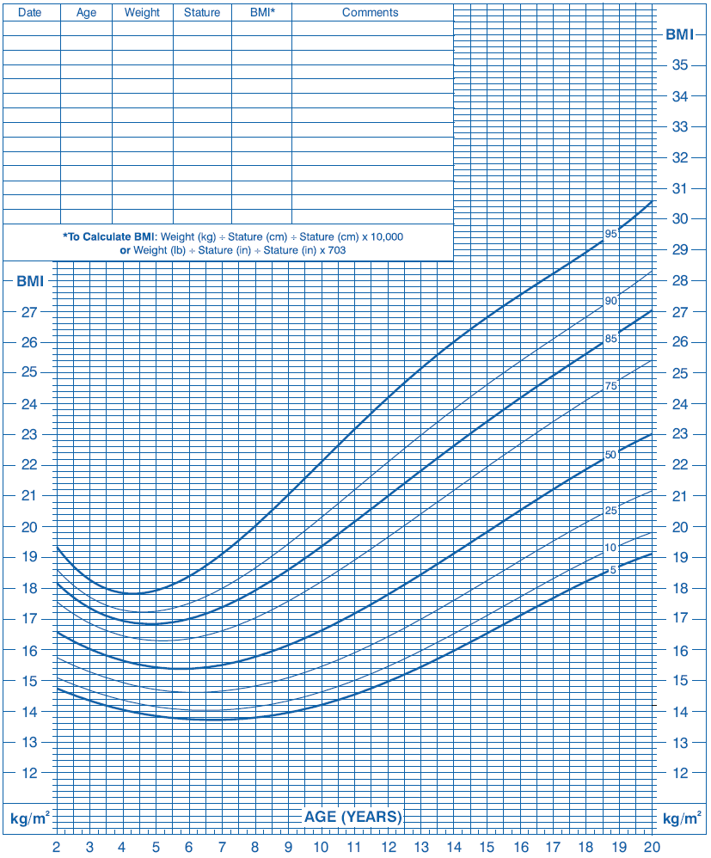
Weight Status Category | Percentile Range
Underweight | Less than the 5th percentile
Healthy weight | 5th percentile to less than the 85th percentile
Overweight | 85th to less than the 95th percentile
Obese | Equal to or greater than the 95th percentile

Each line on the graph moving vertically (up and down) is worth .2
Each line on the graph moving horizontally (left to right) is worth .25

Calculate your BMI

Name: __________________________ Class: _________ Block: ___

To calculate your BMI use the following formula

Your weight (lbs) * 703
BMI= ________________________________________
Height (in inches) * Height (in inches)

Example weight is 190 lbs and height is 70 inches

190 * 703
BMI= ________________________________________
70 * 70

133570
BMI= ________________________________________
4900

BMI= 27.26%

__________________________________________________________________________________
Your BMI:

________lbs * 703
BMI= ________________________________________
________ inches * _______ inches

BMI= ________________________________________

BMI= ________ %

What is your Percentile? _________________

What is your Weight Status Category? ____________

