Welcome to our Editor Highlights page. We currently don’t have all of our editors highlighted, but are looking to do so very soon. So, make sure you check back to see all of our wonderful Editorial Team here at PELINKS4U!!!

ADAPTED SECTION EDITORS

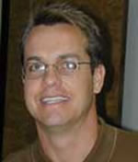 | Phillip Conaster  - 8 years in teaching higher education  - Adapted Section Editor  - Currently: teaching Adapted Physical Activity, Adapted Aquatics, Motor Development, Elementary Kinesiology, and Health & Wellness for Children at West Texas A&M University  - Graduate Degree From: Ph.D. from The University of Virginia  - Professional Interests: Research interest in Adapted Aquatics, Biomechanics, and Wellness for individual with disabilities  - Recreational Interests: Biking, River Running, Swimming, Boating

 | Brent Hardin  - 4 years in teaching higher education  - Adapted PE Section Editor  - Currently: Assistant Professor in the Department of Kinesiology at the University of Alabama  - Dr. Hardin received his Ph.D. from Florida State University in 2000  - Dr. Hardin has written and published more than 20 journal articles and has made over 25 presentations and written more than 10 grants funding sport and disability projects

 | Chris Stopka  - 26 years in teaching higher education  - Adapted PE Section Editor  - Currently: Teaching exercise therapy and adapted physical activity at the University of Florida  - Honors: Recipient of over 60 university, state, regional, and national honors  - Professional Interests: Exercise Therapy, Adapted Physical Activity, Adapted Aquatics  - Recreational Interests: biking, jogging, swimming, rollerblading, skiing, weight lifting

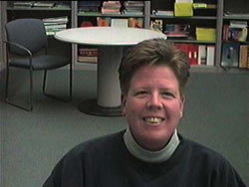 | Sue Tarr  - 10 years in teaching higher education  - Adapted PE Section Editor  - Currently Coordinator for the Physical Education Teacher Preparation and Adapted Physical Education Programs at the University of Wisconsin River Falls  - Professional Interests: Developing quality teachers to solve the obesity epidemic  - Recreational Interests: Biking, hiking, camping, and hanging with my dogs

COACHING SECTION EDITORS

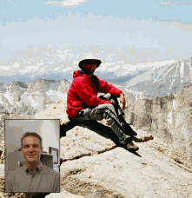 | Wade D. Gilbert  - Years Teaching In Higher Education: 4  - Coaching Section Editor  - Currently: Assistant Professor at California State University, Fresno Coordinator, Graduate Option in Sport Psychology Faculty Advisor, Student Sport Psychology Club  - Presidential Citation for Excellence, AAASP – 2002  - Research Grant, AAHPERD – 2001

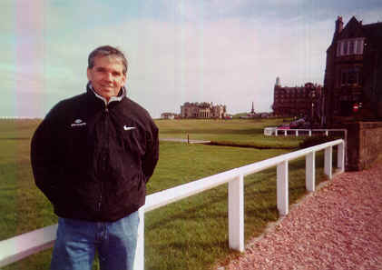 | Robert McGowan  - 20+ years in teaching higher education  - Coaching Section Editor  - Currently: Central Washington University Professor and Department Chair HHPR  - Ph.D. From University of Utah in Exercise Science/Educational Psychology  - Recreational Interests: Golf

Still to come: Martin and Sandra Short
Ferman Konukman
Jenelle Giblert

ELEMENTARY SECTION EDITORS

Clive Hickson

- Master of Arts, University of Victoria, currently working on Ph.D.
- Secondary Section Editor
- Currently: Assistant Professor at the University of Alberta
- Professional Interests: Physical Education for Special Populations

Still to come: Tom Winiecki
Marina Bonello
John Williams

HEALTH SECTION EDITORS

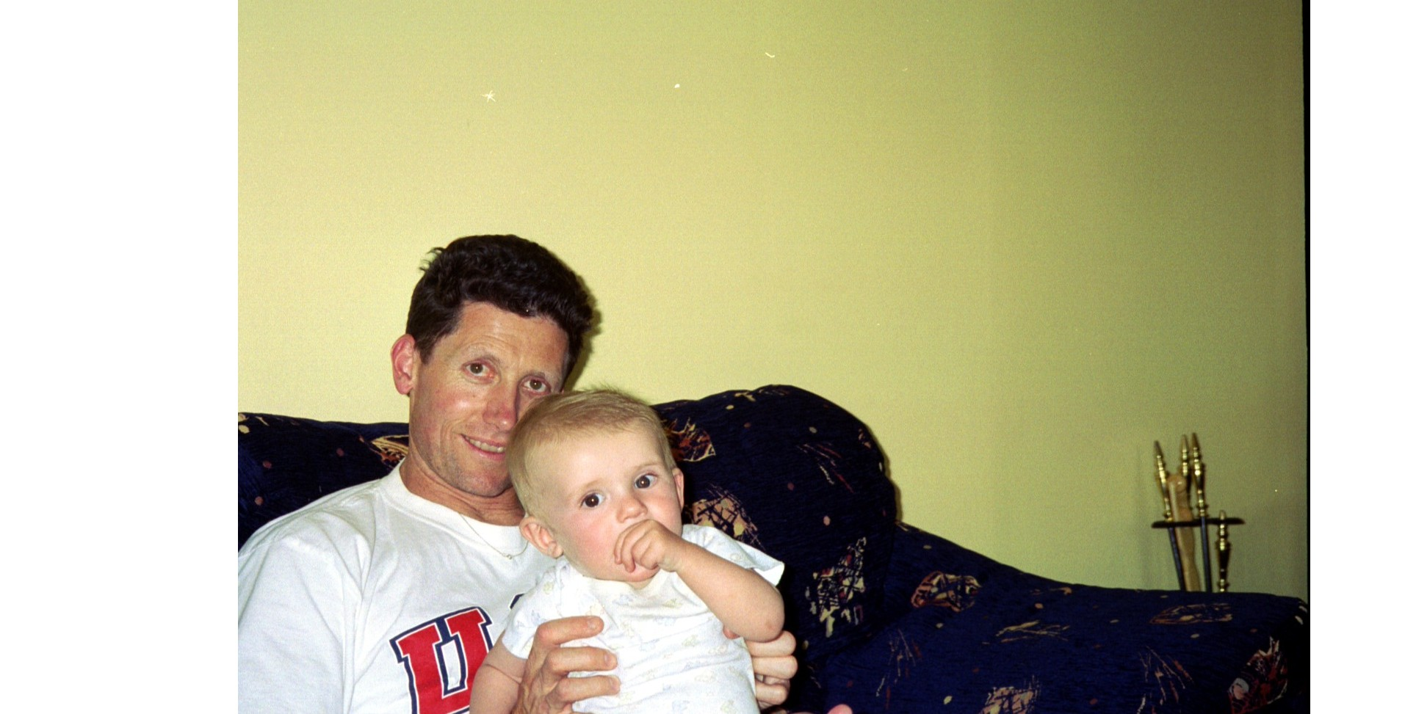 | Darren Dale  - 4+ Years in teaching higher education  - Health/Fitness/Nutrition Section Editor  - Currently Assistant Professor at Eastern Connecticut State University  - Published several papers in journals such as Research Quarterly for Exercise and Sport, and Pediatric Exercise Science  - Research Interests: Include physical activity promotion in schools and  physical activity assessment

Still to come: Lisa Rakoz
Andrea W. Petho

INTERDISCIPLINARY SECTION EDITORS

 | David Kahan  - 10+ years teaching in higher education  - Interdisciplinary Section Editor  - Currently: Assistant Professor in Physical Education at San Diego State University  - Two Campus Level teaching awards in 2003  - Friends of Education Award (1998)  - Recreational Interests: Running, Hiking, Biking, NY Times Crossword Puzzle, Lakers Fanatic, Eating Ethnic Food, and Attending Weekend Cultural Events

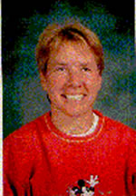 | Cindy Kuhrasch  - 15 Years in Teaching, 4 in Higher Education  - Interdisciplinary Section Editor  - Currently: Assistant Faculty Associate UWisconsin-Madison  - Professional Interests: Integration of PE and other disciplines, brain research, technology, assessment  - Recreational Interests: XC skiing, hiking, biking, tennis

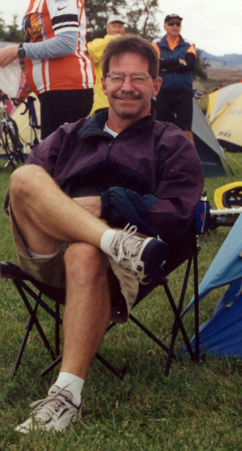 | Danny Mielke  - 20 Years in teaching higher education  - Interdisciplinary Section Editor  - Currently: Division Chair of Physical Education and Health as well as Graduate Coordinator - Master of Science in Education at Eastern Oregon University  - Oregon College Physical Education Teacher of the Year, 1994  - Meritorious Faculty Award: Eastern Oregon University, 1988-1994; 1995-2003  - Recreational Interests: Cycling, Tennis, Cross Country Skiing, Soccer Coaching

Still to come: Shaunna McGhie

SECONDARY SECTION EDITORS

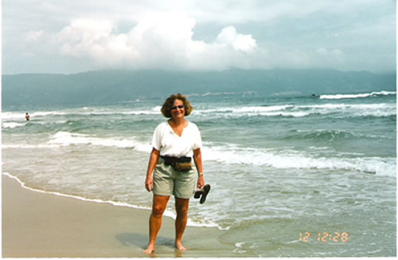 | Isobel Kleinman  - 31 years in a Long Island secondary public school system  - Secondary Section Editor  - Currently: Retired but Writing  - Authored Complete Physical Education Plans for Grades 7-12 and just published Too Dangerous to Teach  - Recreational Interests: Tennis, Attending theatre, Dance concerts, Museums, Playing golf, Biking, and Traveling the world

Jon Poole

- 10 years in teaching higher education
- Adapted PE Section Editor
- Currently Associate Professor and Coordinator for the Physical and Health Education Teaching Program at Radford University
- VAHPERD college physical educator of the year award winner
- Professional Interests: Promoting physically active and healthy living for K-12 students, health-related fitness education, and teaching lifetime sports
and physical activities

TECHNOLOGY SECTION EDITORS

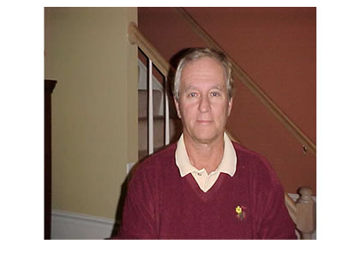 | Gerry Cernicky  - 36 years experience in PE  - PE Central editor PE Links editor for physical education and technology  - SC convention presenter  - PA convention presenter  - Teacher Induction/presenter - A.I.U.  - Pittsburgh Teacher of the Year 1998

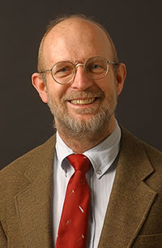 | Michael Dumin  - 27 years in teaching higher education  - Technology Section Editor  - Currently doing elementary and adapted fitness assessment and prescription  - Professional Interests: Technology, Fitness Assessment/prescription, pedagogy  - Recreational Interests: Biking, hiking, camping, running, wood working

Still to come: Debby Mitchell

ALSO STILL TO COME: Dr. Stephen C. Jefferies Co-founder
Dr. Kirk Mathias Co-founder
Scott Melville Book Review Editor
Vanessa Dunn Webmaster
Lloyd Gage Graduate Assistant

