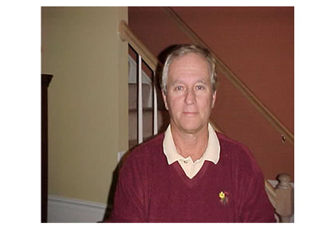 | Gerry Cernicky  - 36 years experience in PE  - PE Central editor PE Links editor for physical education and technology  - SC convention presenter  - PA convention presenter  - Teacher Induction/presenter - A.I.U.  - Pittsburgh Teacher of the Year 1998

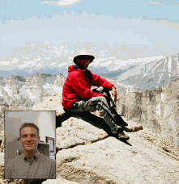 | Wade D. Gilbert  - Years Teaching In Higher Education: 4  - Coaching Section Editor  - Currently: Assistant Professor at California State University, Fresno Coordinator, Graduate Option in Sport Psychology Faculty Advisor, Student Sport Psychology Club  - Presidential Citation for Excellence, AAASP – 2002  - Research Grant, AAHPERD – 2001

 | David Kahan  - 10+ years teaching in higher education  - Interdisciplinary Section Editor  - Currently: Assistant Professor in Physical Education at San Diego State University  - Two Campus Level teaching awards in 2003  - Friends of Education Award (1998)  - Recreational Interests: Running, Hiking, Biking, NY Times Crossword Puzzle, Lakers Fanatic, Eating Ethnic Food, and Attending Weekend Cultural Events

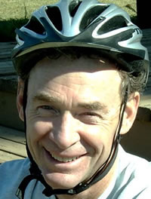 | Scott Melville  - 22 Years teaching in higher education  - Book Review Editor  - Currently: Teaching at Eastern Washington University  - Authored Books in The Science of Coaching Tennis and Elementary Health and Physical Education  - Recreational Interests: Running, Reading, Painting, Swimming, Bicycling, and Hiking

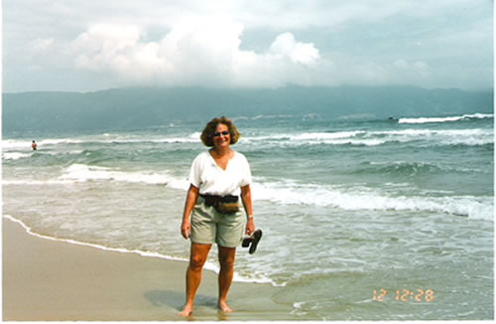 | Isobel Kleinman  - 31 years in a Long Island secondary public school system  - Secondary Section Editor  - Currently: Retired but Writing  - Authored Complete Physical Education Plans for Grades 7-12 and just published Too Dangerous to Teach  - Recreational Interests: Tennis, Attending theatre, Dance concerts, Museums, Playing golf, Biking, and Traveling the world

Clive Hickson

- Master of Arts, University of Victoria, currently working on Ph.D.
- Secondary Section Editor
- Currently: Assistant Professor at the University of Alberta
- Professional Interests: Physical Education for Special Populations

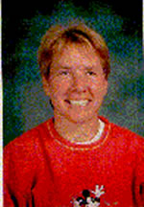 | Cindy Kuhrasch  - 15 Years in Teaching, 4 in Higher Education  - Interdisciplinary Section Editor  - Currently: Assistant Faculty Associate UWisconsin-Madison  - Professional Interests: Integration of PE and other disciplines, brain research, technology, assessment  - Recreational Interests: XC skiing, hiking, biking, tennis

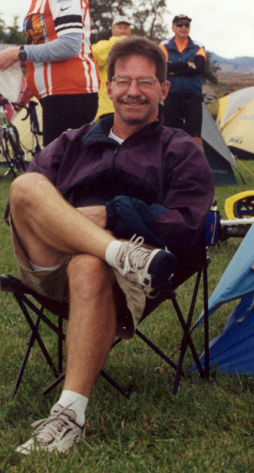 | Danny Mielke  - 20 Years in teaching higher education  - Interdisciplinary Section Editor  - Currently: Division Chair of Physical Education and Health as well as Graduate Coordinator - Master of Science in Education at Eastern Oregon University  - Oregon College Physical Education Teacher of the Year, 1994  - Meritorious Faculty Award: Eastern Oregon University, 1988-1994; 1995-2003  - Recreational Interests: Cycling, Tennis, Cross Country Skiing, Soccer Coaching

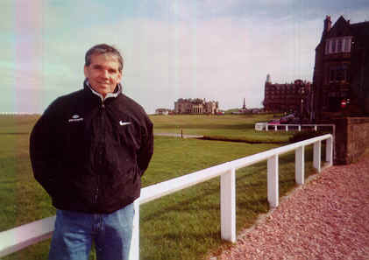 | Robert McGowan  - 20+ years in teaching higher education  - Coaching Section Editor  - Currently: Central Washington University Professor and Department Chair HHPR  - Ph.D. From University of Utah in Exercise Science/Educational Psychology  - Recreational Interests: Golf

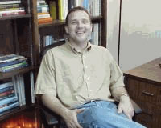 | Brent Hardin  - 4 years in teaching higher education  - Adapted PE Section Editor  - Currently: Assistant Professor in the Department of Kinesiology at the University of Alabama  - Dr. Hardin received his Ph.D. from Florida State University in 2000  - Dr. Hardin has written and published more than 20 journal articles and has made over 25 presentations and written more than 10 grants funding sport and disability projects

 | Chris Stopka  - 26 years in teaching higher education  - Adapted PE Section Editor  - Currently: Teaching exercise therapy and adapted physical activity at the University of Florida  - Honors: Recipient of over 60 university, state, regional, and national honors  - Professional Interests: Exercise Therapy, Adapted Physical Activity, Adapted Aquatics  - Recreational Interests: biking, jogging, swimming, rollerblading, skiing, weight lifting

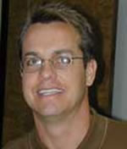 | Phillip Conaster  - 8 years in teaching higher education  - Adapted Section Editor  - Currently: teaching Adapted Physical Activity, Adapted Aquatics, Motor Development, Elementary Kinesiology, and Health & Wellness for Children at West Texas A&M University  - Graduate Degree From: Ph.D. from The University of Virginia  - Professional Interests: Research interest in Adapted Aquatics, Biomechanics, and Wellness for individual with disabilities  - Recreational Interests: Biking, River Running, Swimming, Boating

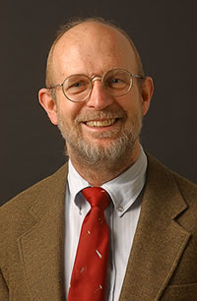 | Michael Dumin  - 27 years in teaching higher education  - Technology Section Editor  - Currently doing elementary and adapted fitness assessment and prescription  - Professional Interests: Technology, Fitness Assessment/prescription, pedagogy  - Recreational Interests: Biking, hiking, camping, running, wood working

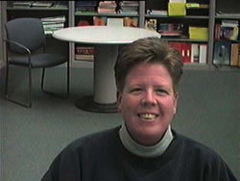 | Sue Tarr  - 10 years in teaching higher education  - Adapted PE Section Editor  - Currently Coordinator for the Physical Education Teacher Preparation and Adapted Physical Education Programs at the University of Wisconsin River Falls  - Professional Interests: Developing quality teachers to solve the obesity epidemic  - Recreational Interests: Biking, hiking, camping, and hanging with my dogs

Jon Poole

- 10 years in teaching higher education
- Adapted PE Section Editor
- Currently Associate Professor and Coordinator for the Physical and Health Education Teaching Program at Radford University
- VAHPERD college physical educator of the year award winner
- Professional Interests: Promoting physically active and healthy living for K-12 students, health-related fitness education, and teaching lifetime sports
and physical activities

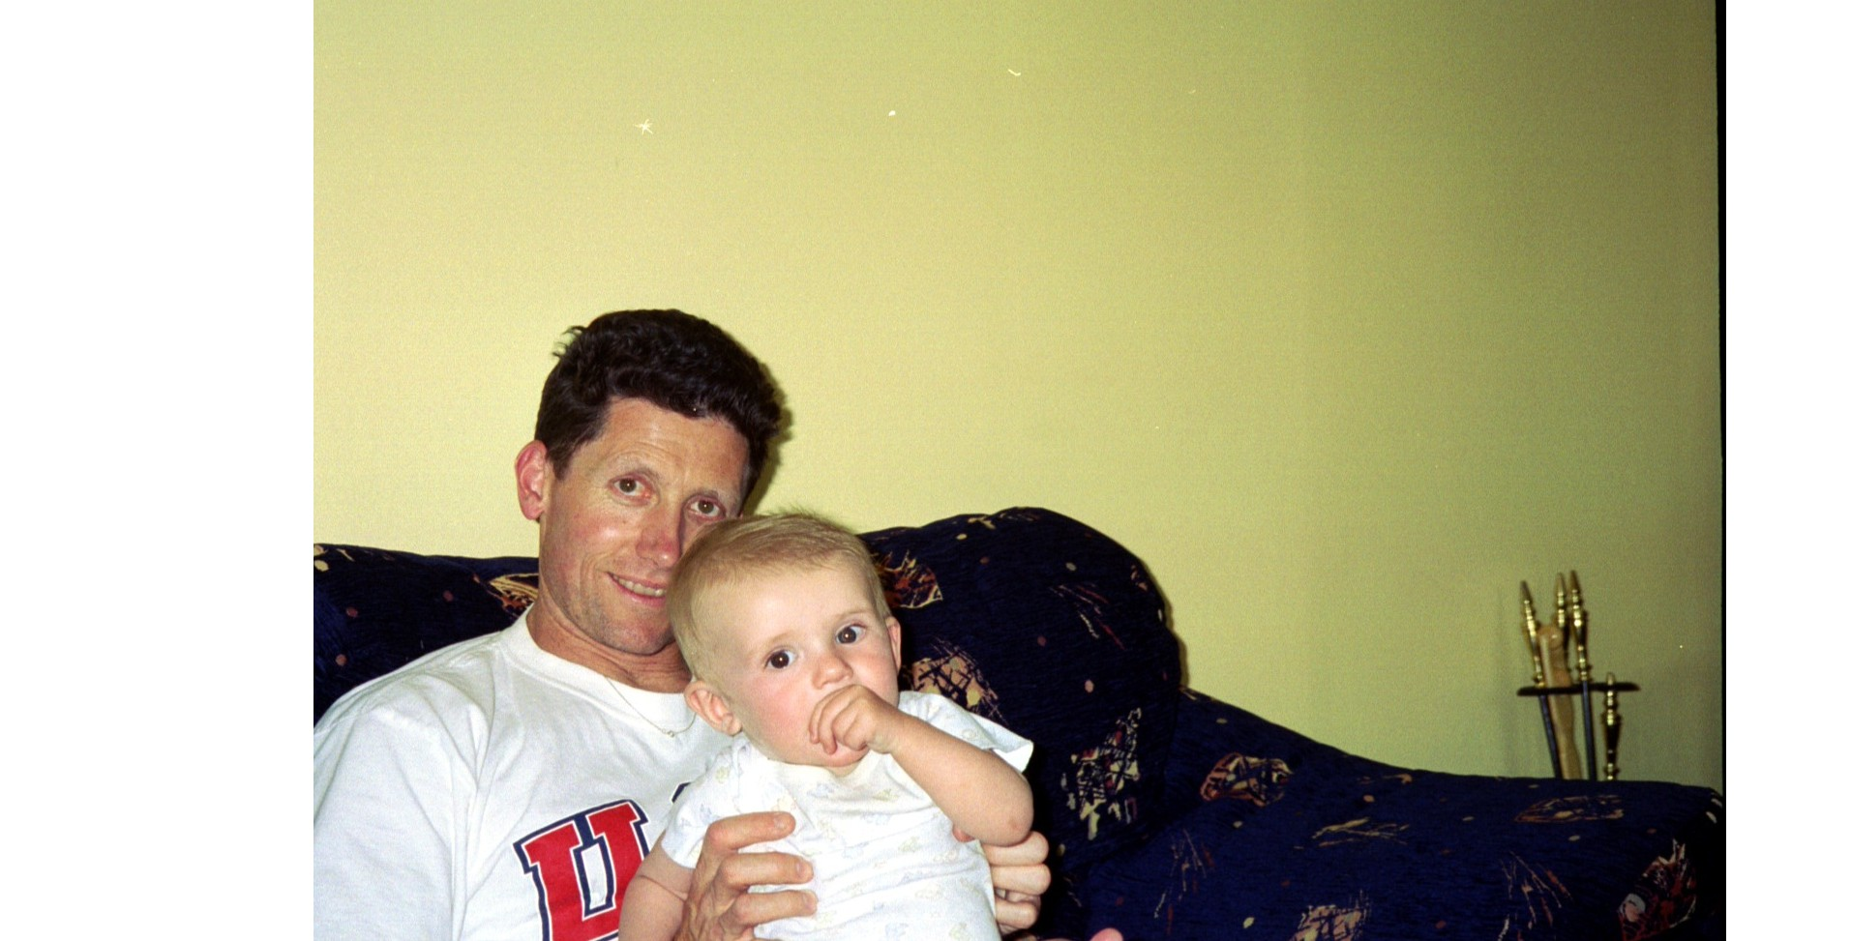 | Darren Dale  - 4+ Years in teaching higher education  - Health/Fitness/Nutrition Section Editor  - Currently Assistant Professor at Eastern Connecticut State University  - Published several papers in journals such as Research Quarterly for Exercise and Sport, and Pediatric Exercise Science  - Research Interests: Include physical activity promotion in schools and  physical activity assessment

