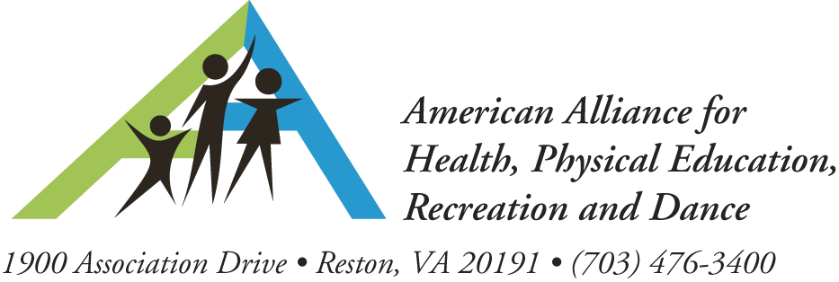

PRESS RELEASE
For more information, contact:
Paula Keyes Kun (703) 476-3461;pkun@aahperd.org
Sinu Patel (703) 476-3485; spatel@aahperd.org

PENNSYLVANIA HEALTH & PHYSICAL EDUCATION TEACHERS BIKE FROM HARRISBURG TO WASHINGTON, DC TO ADVOCATE
FOR HEALTHY ACTIVE KIDS

RESTON, VA, June 5, 2012– During an inaugural 150-mile “Capital to Capitol ONE Bike Ride” next month, members of the Pennsylvania State Association for Health, Physical Education, Recreation and Dance (PSAHPERD) will advocate for and raise awareness for the importance of living a healthy lifestyle to help prevent childhood obesity. Riders will start their trip on Monday, July 9 at the steps of the Pennsylvania State Capitol in Harrisburg, where they will be sent off by representatives of the state’s legislature, and complete their journey two days later at the steps of the U.S. Capitol Building, where they will be greeted by members and staff of their Congressional delegation. Lead by President Kimberley Razzano and Project Director Kelly Boyd, the 2012 PSAHPERD theme titled “All for ONE…That’s How We Roll” is the framework for this event.
They are riding 52 miles the first day and 64 miles the second day. On Wednesday, July 11 the group will ride on the Washington & Old Dominion Trail and make a short stop at the national headquarters of the American Alliance for Health, Physical Education, Recreation and Dance (AAHPERD) in Reston, VA, where AAHPERD staff and area physical educators will join the final leg of the journey, speaking up for the value of quality physical education and health education programs in schools nationwide.
The purpose of the “Capital to Capitol ONE Ride” is to:
- raise awareness about the negative impact childhood obesity has on lifelong wellness
- advocate for positive legislative attention toward childhood obesity prevention
- raise funds which will be used to support education programs

“As members of the Health and Physical Education profession, we understand the long term implications of childhood obesity on lifelong wellness on our country if not enough action is taken to address this epidemic,” says Kimberley Razzano, PSAHPERD president and associate professor at East Stroudsburg University. “The K-12 years are a crucial time in a child’s life. This is when attitudes and behaviors regarding personal health are established. With physical inactivity and poor nutrition as two of the six risk factors identified by CDC which lead to premature death, but are preventable, we hope this event will raise strong awareness about the negative impact of childhood obesity on adult wellness and encourage a lifelong commitment to healthy choices; including healthy eating and physical activity. It is imperative that we increase federal attention towards preventive measures and raise funds to support quality educational programs.”
Through community fundraisers, sponsorships, and personal donations, PSAHPERD hopes to raise $10,000 dollars to benefit programs fighting obesity and promoting lifelong wellness. To be distributed through the PSAHPERD and the PA affiliate of the American Heart Association (AHA), donations can be made through the PSAHPERD 21st Century Endowment Fund.
AAHPERD CEO Paul Roetert adds, “AAHPERD is proud to be a part of this important historic journey. The Capital to Capitol One Bike Ride is a testimony to our commitment as a profession for increased physical education, health education and physical activity opportunities in schools and communities that will lead to a healthier generation of America’s children. We salute our PSAHPERD members for their enthusiasm and energy, and look forward to joining them in Washington.”
To join PSAHPERD members on Wednesday, July 11 in Reston, Virginia as they bike along the Washington & Old Dominion Trail to Capitol Hill, or to volunteer or donate, go to http://www.psahperd.org/Capital_to_Capitol. Contact Kimberley Razzano at 570-994-2171 or via email at krazzano@po-box.esu.edu for more information.

About the Pennsylvania State Association for Health, Physical Education, Recreation, and Dance (PSAHPERD)

The Pennsylvania State Association for Health, Physical Education, Recreation and Dance, Inc (PSAHPERD) is a non-profit (501 c 3) education association working to promote quality programs and provide professional development in the disciplines it represents. The PSAHPERD is committed to the continual professional growth and development of its members, the expansion and application of the knowledge base and pedagogical constructs, and the support of the professions that encourage active healthful lifestyles by all people in the Commonwealth of Pennsylvania.

About American Alliance for Health, Physical Education, Recreation, and Dance (AAHPERD)
AAHPERD, an alliance of five national associations, six district associations, and a Research Consortium, provides its members with a comprehensive and coordinated array of resources, support, and programs to help practitioners improve their skills to further the health and well-being of the American public. It is the largest organization of professionals involved in physical education, recreation, fitness, dance, health promotion and all specialties related to achieving an active, healthy lifestyle. AAHPERD serves 20,000 members and has its headquarters in Reston, Virginia, 25 miles west of Washington, DC. To learn more, visit www.aahperd.org.

-30-

